1. Which of the following is correct?

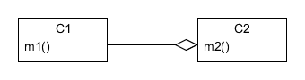

1. C1 can see m1() and m2()
2. C1 can only see m2()
3. C2 can only see m1()
4. C2 can see m1() and m2() correct
5. Study the following design and choose the correct answer from the list shown below the diagram

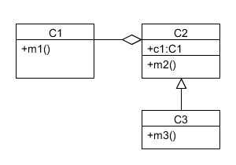

1. An object of class C3 cannot use m1()
2. An object of class C3 can only use m1() if it is called by m2()
3. An object of class C3 can only use m1() if it is called by m3()
4. An object of class C3 can use m1() correct

Cannot make abstract class a object but child class can make object of interface and abstract class